MISSION TRIP 2010
The proceeds from this year’s race will go towards helping a group of our students travel and minister alongside the people of Manchester Baptist Church in Manchester, KY.
This church is located in one of the poorest counties in the United States and has a big vision for serving those who live in the area. From home construction and repair to a clothes closet ministry they are reaching an entire community with the love of Jesus Christ.
We look forward to this time of ministry with the people of Manchester, KY and greatly appreciate your assistance in helping this cause.

Calvary Baptist Church 20957 Timberlake Rd Lynchburg, VA 24502

Calvary Baptist Church 3rd Annual
Road Trip 5K
Saturday, May 15, 2010
5K Run/Walk & 1 Mile Youth Run
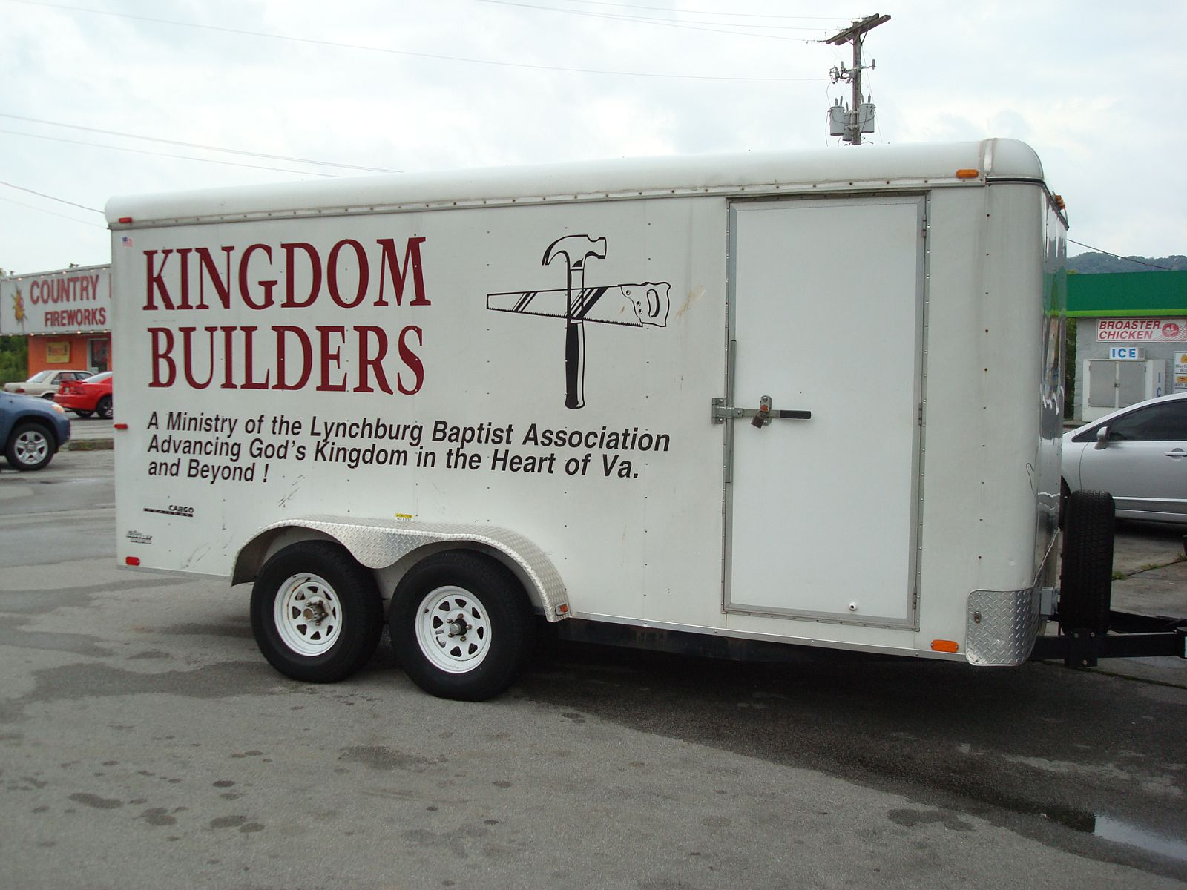
To benefit the 2010 Mission trip to Manchester, KY

EVENT INFORMATION

DATE: Saturday, May 15, 2010
RACE LOCATION: Begin and end at Calvary Baptist Church located on Timberlake Road next to Food Lion
TIME: 5k – 8:00 am, Youth Mile – 9:00 am, Same day registration – Begins at 7:00 am
ENTRY FORMS & FEES: Forms and entry fees turned in to Calvary Baptist Church or Riverside Runners. $15.00 pre-registration (postmarked by Friday, May 7th), $18.00 on race day.
AWARDS: Top three men and women overall and in each age group
FUN: Door prizes, music and post-race Pancake and sausage breakfast.
PACKET PICK-UP: Pre-Race on Friday, May 14 at Calvary Baptist Church from 5-8 pm. Race day pick-up beginning at 7:00 am
RACE INFORMATION: Contact Calvary Baptist Church – 239-9133
RACE RESULTS: www.riversiderunners.com
COURSE RECORDS: Women – Amy Coutee 21:33 (2009); Men – Dwayne Fitts 19:10 (2009)
We hope to see you May 15th for a great event!

REGISTRATION
Form can be submitted to Riverside Runners or Calvary Baptist Church.
If by mail, mail the form, by Friday, May 7th, to:
Calvary Baptist Church
20957 Timberlake Rd
Lynchburg, VA 24502

Last Name: First Name:
Address:
City: State: Zip:
Phone: E-Mail:
Age as of race day Gender: M F
Please make checks payable to Calvary Baptist Church
EVENT: 5k Run 5k Walk 1 mile Youth run
T-shirt size: YM YL S M L XL
RELEASE (must be signed):
I know that running is a potentially hazardous activity. I should not enter or run unless I am medically able & properly trained. I also know that there will be traffic, debris, poor footing and other hazards on the course and assume the risk for running on it. I also assume any or all other risks associated with running or attending the race including but not limited to falls, contact with other participants, the affects of the weather, the conditions of the roads and getting lost, all such risks being known and
appreciated by me. Having read the waiver and knowing these facts, and in consideration of your accepting my entry, I for myself and anyone entitled to act on my behalf, waive and release Calvary Baptist Church’s staff, volunteers and race sponsors, their representatives and successors from all claims or liabilities of any kind arising out of my participation in this event though the liability may arise out of negligence or carelessness on the part of the persons named in the waiver.
Signature (Guardian if under 18) Date:_____________

