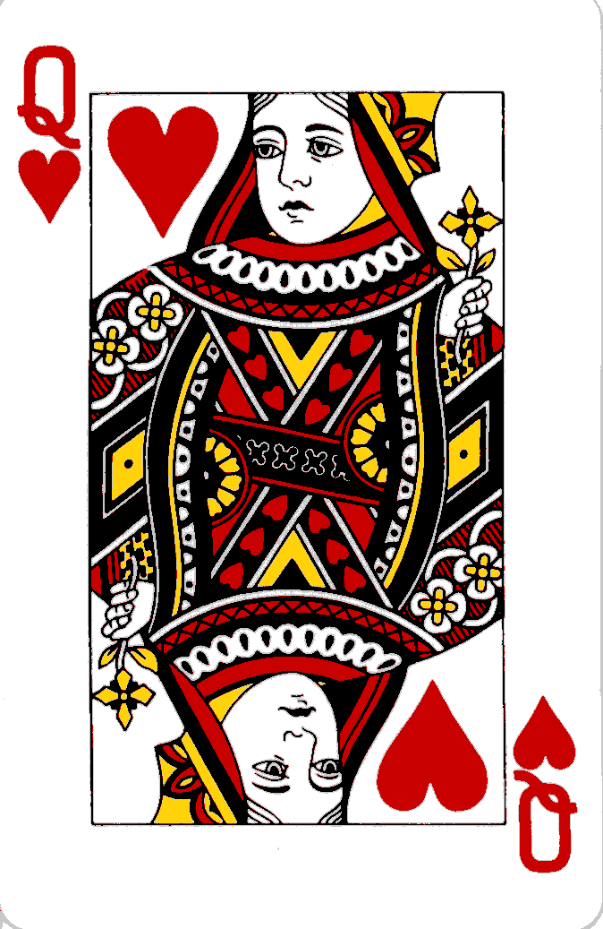
QUEEN of HEARTS Poker Run

Who?
Runners participating in teams of two; partners must complete the entire event together. Hosted by Riverside Runners and the Lynchburg Road Runners.

What?
A team consists of two runners. Each team of two will run to six different checkpoints to pick up a card for their hand. When runners have completed all six stops, they will come back to Riverside Runners. Official rules available race day. Prizes awarded for best hands and randomly.

When?
Saturday, February 13th , 8:30am.

Where?
Start/Finish: Riverside Runners, Course: 6 stops on or near Rivermont Avenue. Total distance approx. 5 miles.

Why? A fun way to spend the day, make new running friends, and stay motivated.

Registration: (Limited to first 50 teams)
Visit Riverside Runners to register online. This is a FREE fun run. Race day registration (if slots are available) begins 8:00am., Register Online at riversiderunners.com

More Info?
Call Riverside Runners, 434-846-7449

