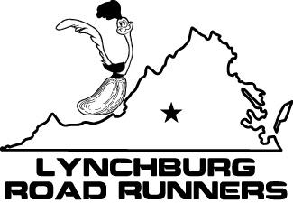
Race Series Race #3 "Lynchburg's Running/Walking Specialty Store."

14th Annual Central Virginia
Kidney Association (CVKA)
MEMORIAL DAY 10K
Monday, May 30, 2011 8 a.m.

LAST NAME____________________________ FIRST NAME______________ PHONE____________

FULL MAILING ADDRESS_____________________________________________________________

CITY______________________________________STATE____________ZIP_____________________

EMAIL ADDRESS (please print)__________________________________________________________

______________ __________ ______
Age on race day Date of birth Sex
(Participant giveaways guaranteed for pre-registered runners only)

REGISTRATION FEE: CHECK ONE: ____$20.00
____$18.00-LRR MEMBERS postmarked by May 25, 2011
Late Registration and Race Day: ____$25.00

ADDITIONAL DONATIONS TO CVKA are TAX DEDUCTIBLE. ______amount of donation
Please send check payable to Central Virginia Kidney Association

WAIVER(must be signed):
I know that running a road race is a potentially hazardous activity. I should not enter and run unless I am medically able and properly trained. I assume all risks associated with running in this event including, but not limited to, falls, contact with other participants, the effects of the weather, including high heat and/or humidity, the conditions of the road and traffic on the course, all such risks being known and appreciated by me. Having read the waiver and knowing these facts, and in consideration of your accepting my entry, I for myself and anyone entitled to act on my behalf, waive and release the Central Va Kidney Association, the Lynchburg Roadrunners, the Holiday Inn Select, the City of Lynchburg and all sponsors, their representatives and successors from all claims or liabilities of any kind arising out of my participation in this event even though the liability may arise out of negligence or carelessness on the part of the persons named in this waiver.

_________________________ _________
Signature (Guardian if under 18) Date
MAIL TO: Riverside Runners, ATTN: Lesley McPhatter, 2301 Rivermont Ave., Lynchburg, VA 24503, Riverside Runners (434)846-7449
Thanks for your support!

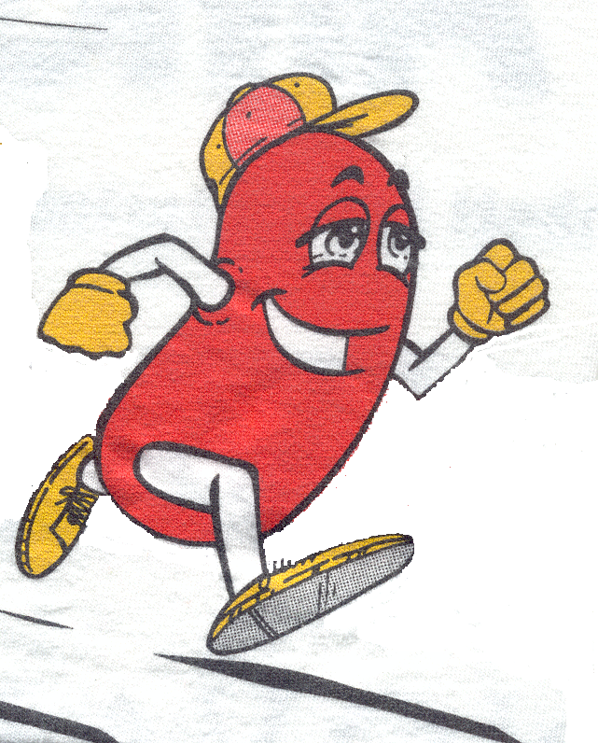14th Annual
Central Virginia
Kidney Association (CVKA)
MEMORIAL DAY 10K
Monday, May 30, 2011, 8 a.m.
Lynchburg Roadrunners Race Series Race #3
LOCATION: HOLIDAY INN SELECT, upper level parking deck. 601 Main Street Lynchburg, VA.

SPONSORED BY: Central Virginia Kidney Association (CVKA) & the Lynchburg Roadrunners

RACE DIRECTOR: Lesley McPhatter-(434)485-1608 or (434)455-7116 llm4n@virginia.edu

WEBSITE: For applications, online registration and results www.riversiderunners.com.

AGE GROUPS: (Men and Women) 26 age groups!! 63 age group awards!
12 and under
13-17 18-24 25-29 30-34 35-39 40-44 45-49 50-54 55-59 60 -64 65-69
70 and over
AWARDS: Top three overall male and female, and top three in each age group, Masters (40 and over), Grand Masters (50 and over) overall male and female.

ENTRY FEE:
$20.00 ($18.00 LRR members) if postmarked by May 25, 2011. Late registration and race day registration $25.00. Race day registration 7-7:30 am. Packet pickup 7 am-7:45 am. Make checks payable to Central Virginia Kidney Association.

PACKET PICKUP:
Riverside Runners, 2301 Rivermont Ave. Friday May 27, 4-7 pm, Sat. May 28, 10:00am – 4:00pm.

COURSE: Out and back from downtown to Riverside Drive. The course has moderate hills, with a downhill finish. The streets are NOT closed.

AID: There will be two water stops around 2 and 4 miles. There will be splits at each mile.

ACCOMODATIONS: Holiday Inn Select (race start). Call (434)528-2500 for reservations and rates.
DIRECTIONS: From Business Rt 29 N or S take Main Street Exit #1 in Lynchburg. Proceed to 600 block.
CVKA is a nonprofit organization to provide resources for people with kidney disease. All profits from this race will go to this fund. All donations are tax deductible.
Central VA Kidney Association 10K
Contact: Lesley McPhatter 434-485-1608, llm4n@virginia.edu

